* course_table
  + remove Duration
* change qualifications table to track_strand

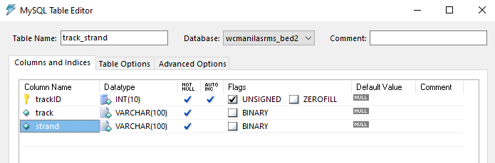

* Change subjects

|  |  |
| --- | --- |
| **From** | **To** |
|  |  |
| ALTER TABLE subjects MODIFY sem varchar(45) AFTER course |  |

* Modify the sections table

|  |  |
| --- | --- |
| **From** | **To** |
|  |  |
| Need to run script to mass update the existing records of Advisers | UPDATE IGNORE  sections t1,  staff t2  SET  t1.IDNumber = t2.IDNumber  WHERE  t1.IDNumber = concat(t2.FirstName,' ',t2.MiddleName,' ',t2.LastName); |

* Change semsubjects

|  |  |
| --- | --- |
| **From** | **To** |
|  |  |

* Change studeprofile

|  |  |
| --- | --- |
| **From** | **To** |
| Remove:  - AdmissionDate  - GraduationDate  - ImagePath  - Requirements |  |

* Change semstudent

|  |  |
| --- | --- |
| **From** | **To** |
|  |  |

* Chang registration table

|  |  |
| --- | --- |
| From | To |
|  |  |
|  |  |

* Change grades table

|  |  |
| --- | --- |
| From | To |
|  |  |

* Studeaccount

|  |  |
| --- | --- |
| From | To |
|  |  |

* Paymentsaccounts

|  |  |
| --- | --- |
| From | To |
|  |  |

For expenses table, add settingsID

track_strand from qualifications table